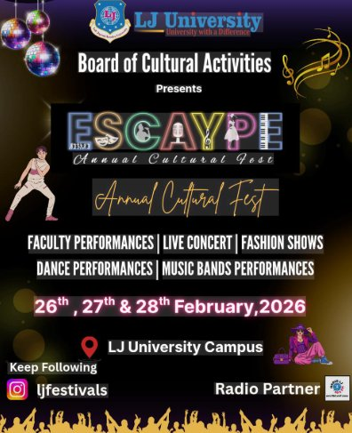
ESCAYPE 2026
Annual Cultural Fest

LJ University, Ahmedabad
26th – 28th February, 2026

EVENT REPORT
Prepared By: Vishal Chudasama
Enrollment No: 25004401110069
Roll No: A05
Course: MCA Semester II
Subject: Communication and Technical Report Writing
LJ University, Ahmedabad - March 2026

- ABSTRACT
ESCAYPE 2026, the Annual Cultural Fest organized by LJ University, Ahmedabad, was a three-day event held from 26th to 28th February 2026. The festival brought together students, faculty, and alumni to celebrate creativity, talent, and cultural diversity through various performances such as dance, music, fashion shows, and live concerts. This report presents a comprehensive overview of the event, including its planning, execution, key activities, and outcomes. The event witnessed high participation and a significant increase in audience engagement across all three days, making it one of the most successful editions of ESCAYPE. Overall, the festival provided students with valuable opportunities for personal growth, teamwork, and practical experience in event management.

- INTRODUCTION
ESCAYPE 2026 was the flagship annual cultural festival of LJ University, Ahmedabad, organized to celebrate creativity, talent, and collaboration among students. The event was conducted over three days, from 26th to 28th February 2026, and featured a wide range of cultural and entertainment activities including dance performances, music bands, fashion shows, and a grand live concert.

College festivals play a vital role in the holistic development of students by encouraging participation beyond academics. ESCAYPE serves as an important platform where students can showcase their skills, build confidence, and engage in creative expression. The festival also promotes cultural diversity and strengthens interaction among students from different departments and institutes.

The 2026 edition of ESCAYPE continued this tradition by offering a well-organized and vibrant environment that combined entertainment with learning. It not only provided memorable experiences but also contributed to the development of leadership, teamwork, and communication skills among participants.

- EVENT DETAILS
Event Name | : ESCAYPE 2026 — Annual Cultural Fest
Organized By | : Board of Cultural Activities, LJ University
Venue | : LJ University Campus, Ahmedabad, Gujarat
Dates | : 26th, 27th & 28th February, 2026
Theme | : Escape into Culture — A Celebration of Art & Life
Social Handle | : @ljfestivals (Instagram)
Radio Partner | : Campus Radio (Official Partner)

- OBJECTIVES OF THE EVENT
The main objectives of ESCAYPE 2026 were as follows:
- To provide a platform for students to showcase their talents in cultural and creative fields
- To promote cultural diversity through various performances such as music, dance, and fashion
- To encourage creativity, innovation, and artistic expression among students
- To develop teamwork, leadership, and communication skills
- To create a vibrant and engaging campus environment beyond academics
- To provide exposure to professional-level performances and event management

- PLANNING & PREPARATION
The success of ESCAYPE 2026 was the result of detailed planning, coordination, and teamwork among students, faculty, and organizers. The event was managed by the Board of Cultural Activities in collaboration with various committees and volunteers.

Several important steps were taken during the preparation phase:

- Formation of organizing committees for event management, logistics, publicity, and coordination
- Conducting auditions and selection processes for student performances
- Promotion of the event through social media platforms such as Instagram and campus posters
- Coordination with the official Radio Partner for announcements and promotions
- Arrangement of stage setup including lighting, LED screens, and sound systems
- Allocation of roles and responsibilities to more than 100 volunteers
- EVENT DESCRIPTION
ESCAYPE 2026 was conducted over three days, each day featuring unique events and activities that contributed to the overall success of the festival.

6.1 Day 1 – Opening Ceremony & Performances (26th February)
The event commenced with an energetic opening ceremony attended by faculty members, students, and university dignitaries. The inauguration marked the beginning of three days of cultural celebration.

The first day included student and faculty performances such as dance, drama, and singing. The energy among participants was high, and the audience actively engaged with the performances. Although the crowd size was moderate compared to later days, the enthusiasm and participation set a strong foundation for the festival.

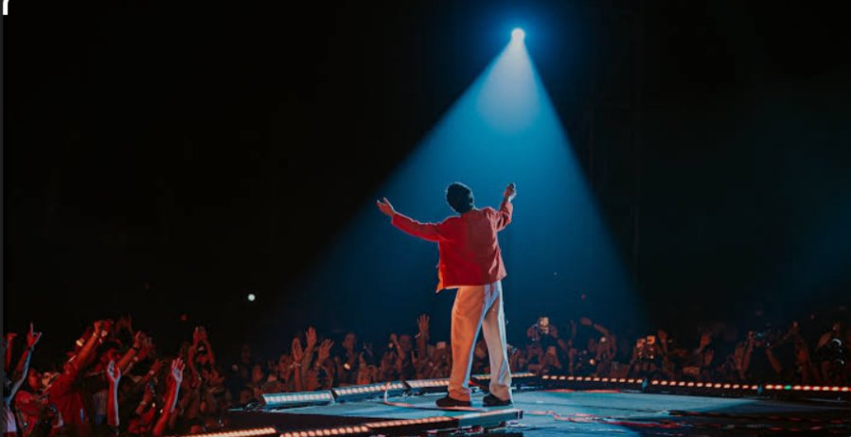
Figure 1: Live Stage Performance – Opening Day of ESCAYPE 2026

6.2 Day 2 – Competitions & Creative Events (27th February)

The second day focused on competitive and visually engaging events such as the Fashion Show and Battle of Bands. Students showcased their creativity through unique fashion designs and musical performances.

There was a noticeable increase in audience engagement compared to Day 1. The combination of competitive events and entertainment attracted more participants and spectators, creating a vibrant and lively atmosphere across the campus.
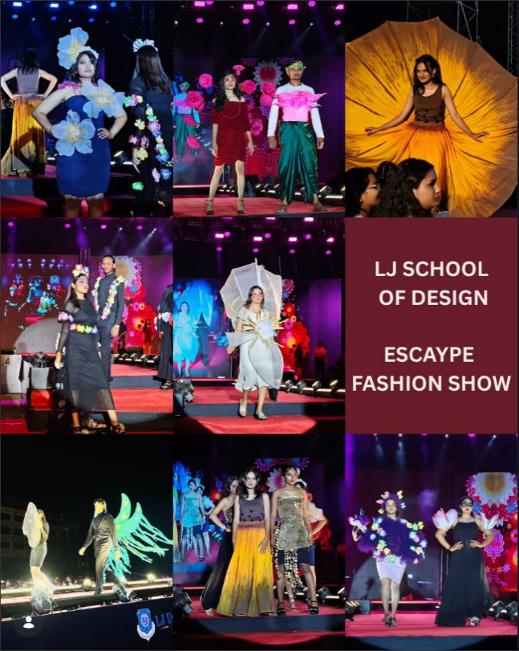
Figure 2: Fashion Show Performance

6.3 Day 3 – Grand Finale & Live Concert (28th February)

The final day of ESCAYPE 2026 featured the grand finale, highlighted by a live concert performance. This segment attracted the largest audience of the entire festival.

Thousands of students, faculty members, and alumni gathered to witness the event. The live concert created an electrifying environment, with high energy, excitement, and strong audience interaction. This day marked the peak success of the festival and left a lasting impression on all attendees.

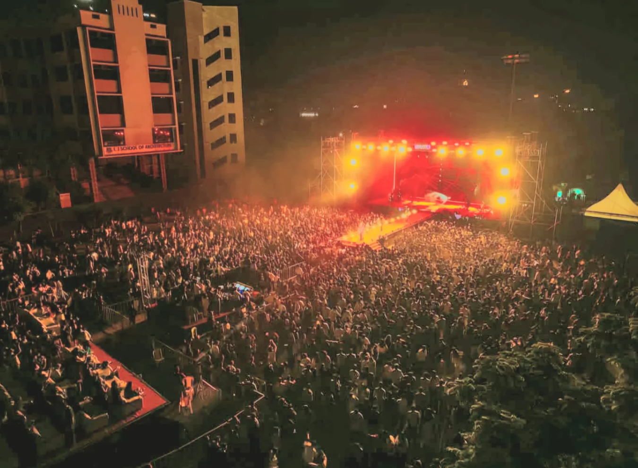
Figure 3: Live Concert – Grand Finale
- KEY HIGHLIGHTS
- Three days of continuous cultural celebrations with diverse activities
- High-quality stage production with advanced lighting, LED screens, and sound systems
- Grand live concert that attracted the highest audience turnout
- Fashion show showcasing a blend of traditional and modern styles
- Energetic performances by student music bands and dance groups
- Special faculty performances that enhanced student-faculty bonding
- Strong social media engagement through @ljfestivals

- OBSERVATIONS
During ESCAYPE 2026, several important observations were made regarding the event management, participation, and overall experience:
- There was a high level of student enthusiasm and active participation throughout all three days
- There was a clear increase in audience engagement from Day 1 to Day 3
- Effective coordination among organizing teams ensured smooth execution of events
- Faculty involvement added a positive and interactive dimension to the festival
- Security and crowd management were handled efficiently, ensuring safety for all attendees
- Social media and radio promotions played a key role in increasing awareness and participation

- RESULTS & OUTCOMES
ESCAYPE 2026 successfully achieved its objectives and delivered several positive outcomes:
- A large number of students, faculty members, and alumni attended the event across all three days
- Over 200 students actively participated in various performances including dance, music, fashion, and theatre
- There was a significant increase in audience engagement, reaching its peak on the final day
- Students developed confidence, stage presence, and communication skills
- The event provided practical experience in event management, teamwork, and leadership
- The festival enhanced the cultural identity and reputation of LJ University
- It created memorable experiences and strengthened connections among students and faculty
Overall, the event proved to be highly successful in terms of participation, organization, and impact.

- STATISTICAL OVERVIEW
The statistical data of ESCAYPE 2026 provides valuable insights into audience engagement and participation trends throughout the event. The data reflects a steady growth in attendance and highlights the distribution of participants across different performance categories.

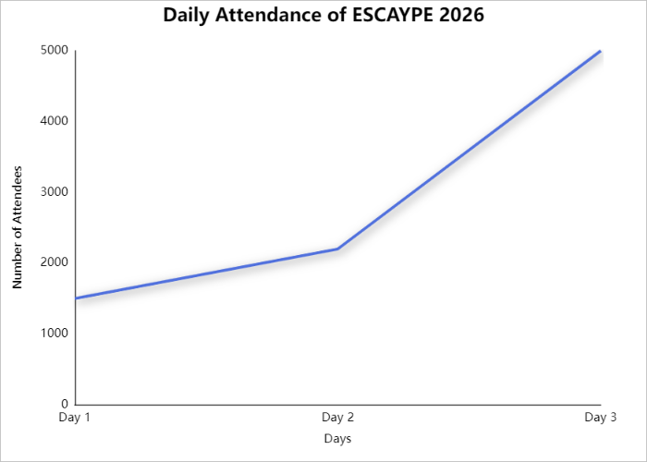
Figure 1: Daily Attendance Growth

The above chart illustrates a continuous increase in attendance over the three days of the festival. The number of attendees rose from approximately 1500 on Day 1 to 2200 on Day 2, and reached over 5000 on Day 3. This growth indicates increasing excitement and engagement, with the grand finale and live concert being the major attraction.

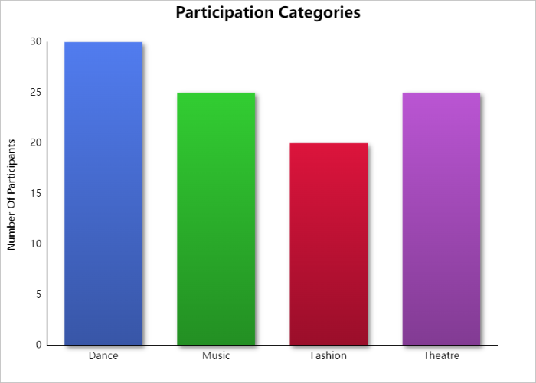
Figure 2: Participation Categories

The chart represents the distribution of participants across different categories. Dance had the highest participation (30%), followed by Music and Theatre (25% each), while Fashion accounted for 20%. This shows a balanced interest among students in various cultural activities.

Overall, the statistical analysis clearly demonstrates the success and popularity of ESCAYPE 2026, highlighting both strong participation and increasing audience engagement.

- CONCLUSION
ESCAYPE 2026 was a well-organized and highly successful cultural event conducted at LJ University, Ahmedabad. The three-day festival provided a vibrant platform for students to showcase their talents in various fields such as dance, music, fashion, and theatre.

The event demonstrated a steady increase in participation and audience engagement, with the highest turnout recorded on the final day. The effective planning, coordination among organizing teams, and enthusiastic involvement of students and faculty played a crucial role in its success.

ESCAYPE 2026 not only offered entertainment but also contributed significantly to the personal and professional development of students. It enhanced skills such as teamwork, leadership, communication, and creativity.

Overall, the event achieved its objectives and left a lasting impact on all participants, strengthening the cultural environment of the university.

— End of Report —

